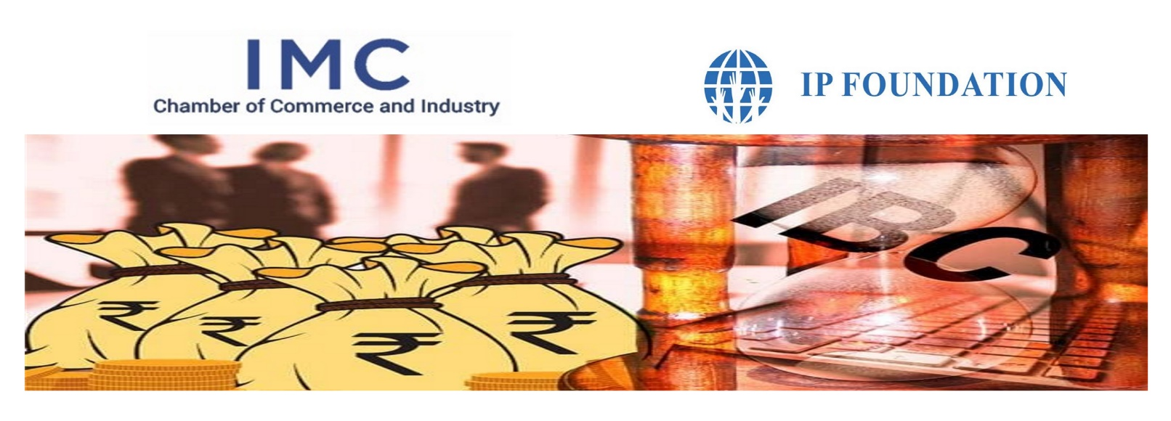
PANEL DISCUSSION on Pre-Packaged Insolvency Resolutions Scheme (IBC)
Date & Time: Thursday, January 28, 2021, 5.00 to 7.00pm
Venue: Babubhai Chinai Committee Room, 2nd Floor, IMC Bldg, IMC, Churchgate.

Dear Sir/ Madam,

The Ministry of Corporate Affairs has issued a White Paper on Pre-Packaged Insolvency Resolutions Scheme. The aim of the proposal is to aid the existing insolvency framework and cut the cost and time of the resolution process. While there is no specific statutory definition, a pre-packaged will allow the creditor and the debtor to informally work on a resolution without the involvement of a court or a tribunal. The plan, if the parties agree, can be presented to the adjudicating authority for approval. It is a hybrid of the informal and formal insolvency process and can be applied even before a default.

In this background IMC Chamber of Commerce and Industry in association with IP Foundation is organising a Panel Discussion to discuss on aforesaid Scheme and issues faced during liquidation.

The key Panellist are:
- Mr. Sapan Gupta, VP, ArcelorMittal Group
- Mr. Sanjeev Pandey, DGM-NCLT, State Bank of India
- CA Avil Menezes, Avil Menezes & Co

The Session would be moderated by CA Snehal Kamdar, Managing Trustee IP Foundation. Recommendations emanating from the discussion will be forwarded to concerned authorities and policymakers.

Who can Participate:
CA, CS, COST ACCOUNTANTS, INSOLVENCY PROFESSIONAL, CFO, CLO, ADVOCATES.

We cordially invite you to attend this panel discussion. Registrations are mandatory due to limited number of seats and will be on First come First serve basis. The fees for the seminar are Rs.1,500/- per participant (inclusive of GST). For further details please contact Ms. Anita Naik at anita.naik@imcnet.org. Kindly use the following website for online registration: https://www.imcnet.org/events-1052.

We look forward to welcoming you.

Ajit Mangrulkar
Director General

